Name: _______________________ Due: Friday Week 2

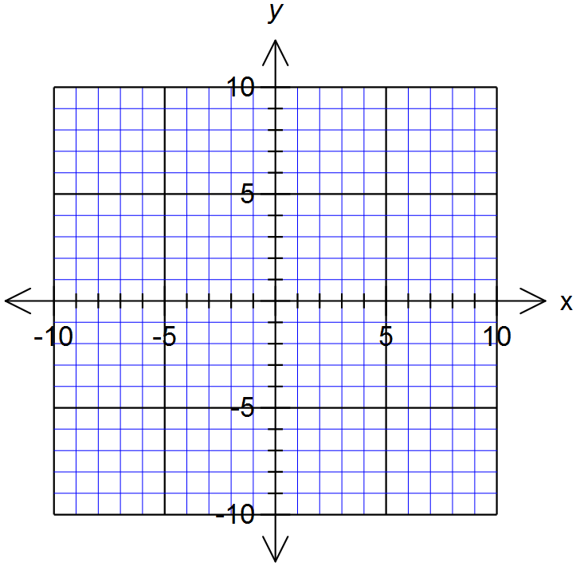
Homework

- Fill in the table then plot it as a linear graph

x | -1 | 0 | 1 | 2 | 3
y | -2 |  | 4 | 7

2. Fill in the table from the graph to the left

x | -2 | -1 | 0 | 1 | 2
y

3. Use the rule y = 2x + 3 to fill in the table below and then graph it

x | -1 | 0 | 1 | 2 | 3
y |  | 3

4. Now try y = x – 4 and plot on the same axes

x | -1 | 0 | 1 | 2 | 3
y

5. Complete the table (continue the pattern) and find an equation (rule) that turns x into y.

x | -4 | -3 | -2 | -1 | 0 | 1 | 2 | 3 | 4
y |  |  |  | -5 |  | -1 | 1 | 3

+ ____ + _____

Difference Pattern: _____________ When x = 0, y = _________

Rule : y = _____x +______

6. Complete the table (continue the pattern) and find an equation (rule) that turns x into y.

x | -4 | -3 | -2 | -1 | 0 | 1 | 2 | 3 | 4
y |  | -21 |  |  |  | 3 | 9 | 15

Difference Pattern: _____________ When x = 0, y = _________

Rule : y = _____________
B

7. Find the gradient and y-intercepts for these lines
A
Hint: y-intercept: Where the line crosses the y-axis

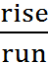

- Gradient = __________

Y-intercept = _________

- Gradient = __________

Y-intercept = _________

- Gradient = __________

Y-intercept = _________

- Gradient = __________
C
Y-intercept = _________
D

